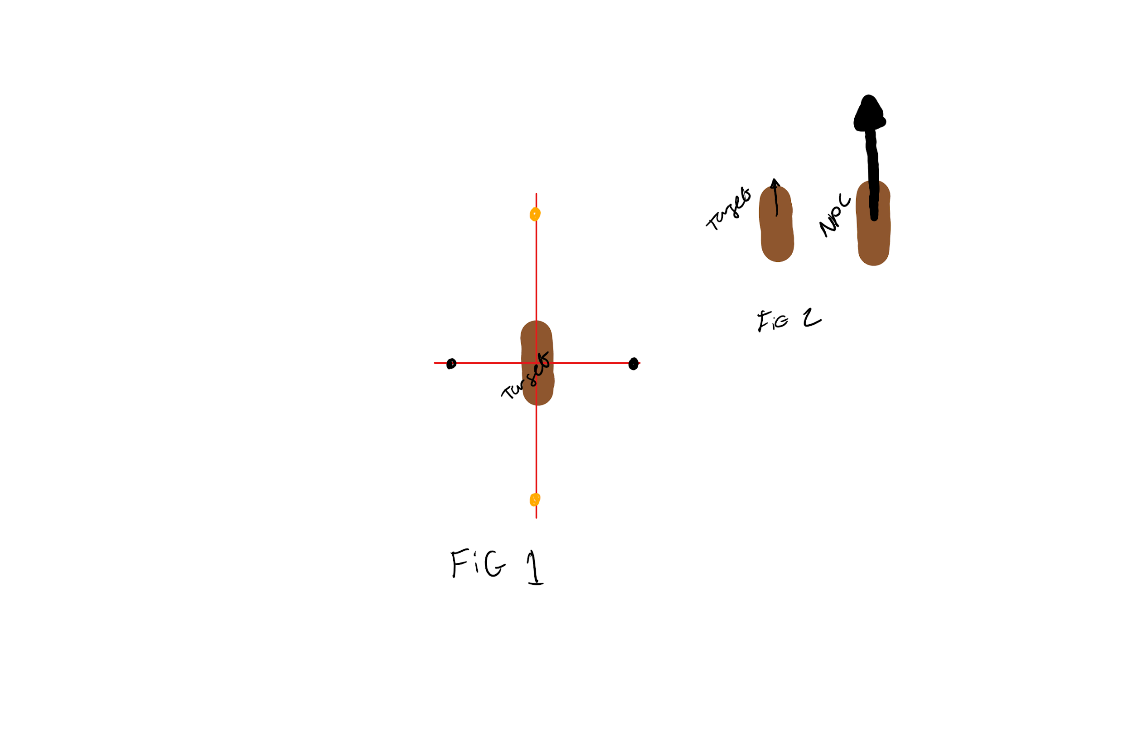

For the behaviour of the AI we wanted the NPC to be able to stay on the edges of the target as much as possible to make it feel more realistic. This is so that when at the black dots in FIG 1 the AI will be trying to match the target's speed as best it can. This is why A is used this is = to the targets speed or as close to it as the enemy boat can get. At the orangey/yellow dots this is where the boats want to be slowing down so they don’t go to far away/or give a chance for the player to be able to escape from them. This is all taken into account and turned into idealspeed. Then actions are taken to try and get the AI to the correct speed. In FIG 2 you can see the NPC is going much faster so it will take actions to brake to the correct speed.

If in dodging mode then ignore this and slow down. This is done cause usually the boats will be moving. This may want to be improved in the future. For example if the NPC is at low speed rather than brake make it accelerate.